Magpie Project Task #4 Responses that Transform Statements

1. Get to know the revised Magpie class. Run it and describe how it responds to the following:

* I want to build a robot.—What does it take to do _______?
* I want to understand French. —What does it take to do _______?
* Do you like me? —What makes you think I ______ you?
* You confuse me? —What makes you think I ______ you?

2. Provide a screen shot here of the required updates made to the Magpie4. Provide screen shots of the code and evidence that your chatbot responds as intended.

* Have it respond to "I want something" statements.
* Have it respond to "I something you" statements.

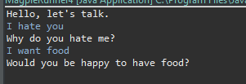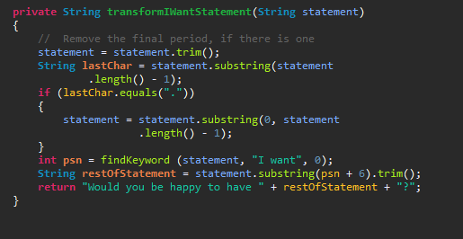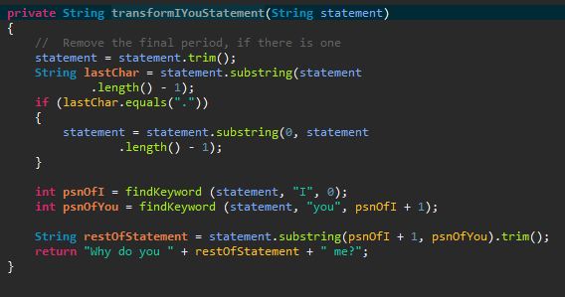

3. Describe a situation where responding to "I something you" statements does not work well. How can you improve the chatbot response to be more humanistic?

It doesn’t work well where there would be complex verb forms or verb conjugation changes from question to answer. You would have to provide the chatbot with the ability to alter the verbs as well.

|  |  |  |  |  |
| --- | --- | --- | --- | --- |
| 50-59% | 60-69% | 70-79% | 80-89% | 90-100% |
| At least one of the modifications were attempted. Questions are not answered. | Less than half of the modifications were attempted. At least one of the questions were answered. | Most modifications were attempted. Both questions were answered, but were not thorough. | All required modifications were attempted. Both questions were answered, at least one was thorough. | All required modifications were made as directed. Both questions were answered and both were thoroughly answered. |